

CSA0501-DATABASE MANAGEMENT SYSTEMS

LAB EXPERIMENTS DATE: 24/07/2026

EXPERIMENT 9 – Query with Joins – EquiJoin, InnerJoin, OuterJoin
AIM: To perform JOIN operations using Equi Join, Inner Join, and Outer Join on the Pet Management System database.

PROCEDURE:
- Select the pet_management database.
- Ensure pet_details and place_details tables are available.
- Perform Equi Join using the common place column.
- Perform Inner Join to display matching records.
- Perform Left Join and Right Join to display outer records.
- Verify the output of each query.
PROGRAM:

1. Display all records:

USE pet_management;

SELECT * FROM pet_details;

OUTPUT:

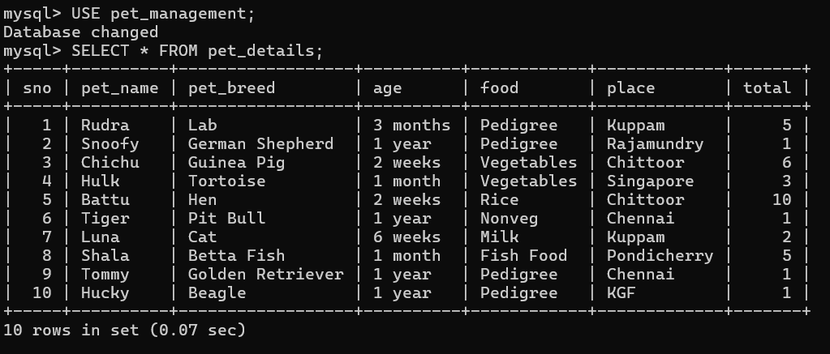

2. Create place_details
CREATE TABLE place_details (
place VARCHAR(30) PRIMARY KEY
);
INSERT INTO place_details VALUES
('Kuppam'),
('Rajamundry'),
('Chittoor'),
('Singapore'),
('Chennai'),
('Pondicherry'),
('KGF');
OUTPUT:

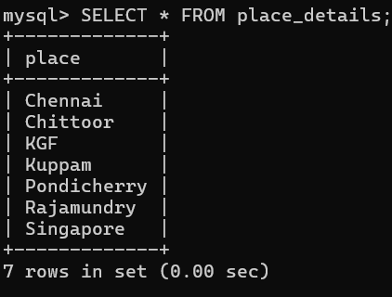

3. Equi Join
Display pet names along with their places.
SELECT p.pet_name, p.pet_breed, d.place
FROM pet_details p
JOIN place_details d
ON p.place = d.place;
OUTPUT:

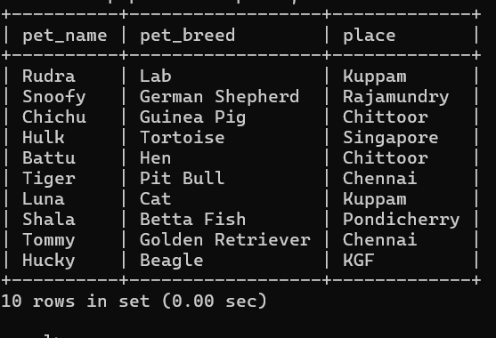
4. Inner Join
Display pets and their corresponding places using Inner Join.
SELECT p.pet_name, p.food, d.place
FROM pet_details p
INNER JOIN place_details d
ON p.place = d.place;

OUTPUT:
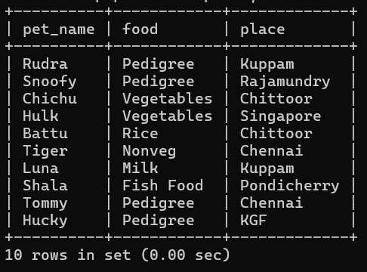

5. Left Outer Join
Display all places and matching pet details.
SELECT d.place, p.pet_name, p.pet_breed
FROM place_details d
LEFT JOIN pet_details p
ON d.place = p.place;
OUTPUT:
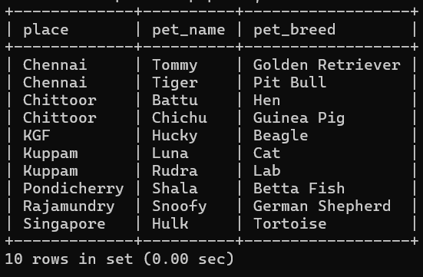
6. Right Outer Join
Display all pets and their matching places.
SELECT p.pet_name, p.pet_breed, d.place
FROM place_details d
RIGHT JOIN pet_details p
ON d.place = p.place;
OUTPUT:
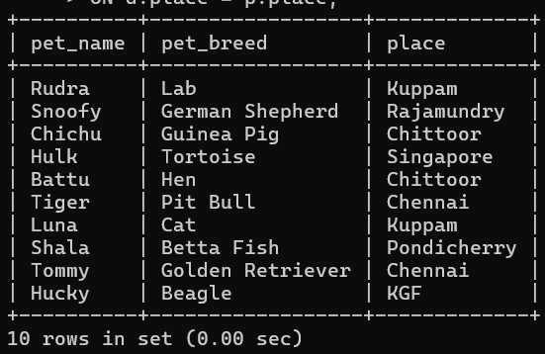

RESULT: The records from the tables are displayed using JOIN using EquiJoin, InnerJoin, OuterJoin.

